Project Report: Automatic MAC Address Masking Tool in Kali Linux
Developer: Amina Malik
Date: August 2025

1. Project Overview
The Automatic MAC Address Masking Tool is a custom Bash-based utility designed to enhance network privacy by randomizing the MAC address of network interfaces. This tool includes both on-demand MAC masking and automatic MAC address rotation whenever the system connects to a network. It demonstrates practical knowledge of Linux networking, scripting, and cybersecurity practices.
2. Objective
- To create a reliable and user-friendly tool that masks the MAC address automatically.
- To enhance privacy by changing MAC addresses during network connection events without user intervention.
- To practice real-world scripting, automation, and ethical hacking techniques.
3. Tools and Technologies
- Operating System: Kali Linux
- Scripting Language: Bash
- Utilities: macchanger, ip, NetworkManager Dispatcher
- Text Editor: Nano / VS Code
- Version Control (optional): GitHub

4. Features
- On-demand MAC address masking via a simple Bash script.
- Automatic root privilege check before execution.
- Interface management (down/up) for safe MAC switching.
- Real-time MAC verification using macmasker -s.
- Automatic MAC Masking on Network Connection
  - Integrated with NetworkManager dispatcher to trigger MAC rotation whenever the system connects to a network.

5. Implementation
- Script Development:
  - A Bash script (macmasker.sh) was created to randomize the MAC address manually using macchanger.
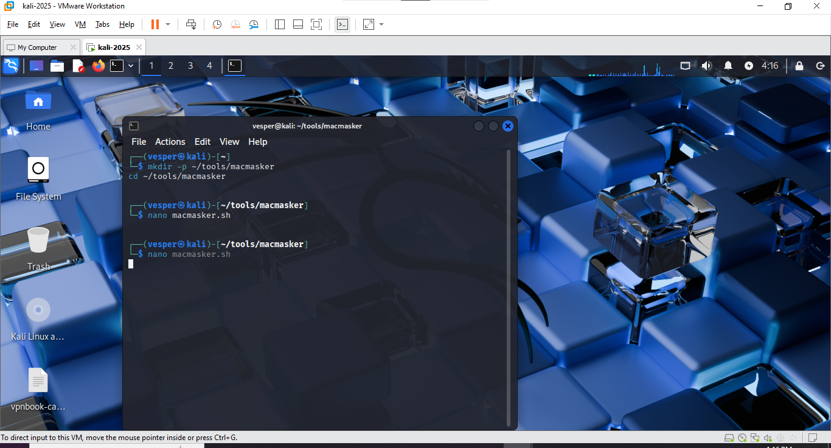
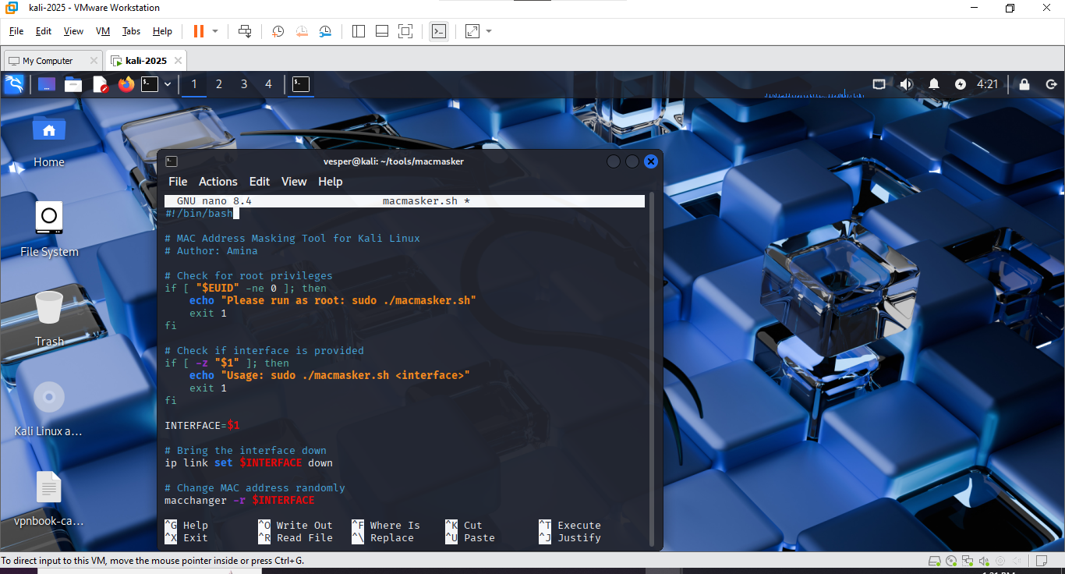
- Automatic Masking Integration:
  - A dispatcher script was added to /etc/NetworkManager/dispatcher.d/, which triggers on up events to randomize the MAC address automatically whenever a network connection is established.
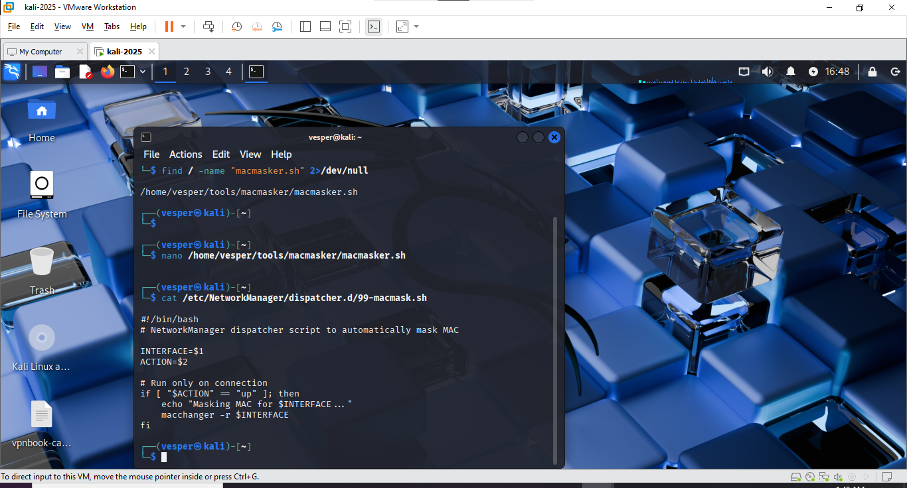
- Verification:
  - Commands used:
  - ip a # to identify interface
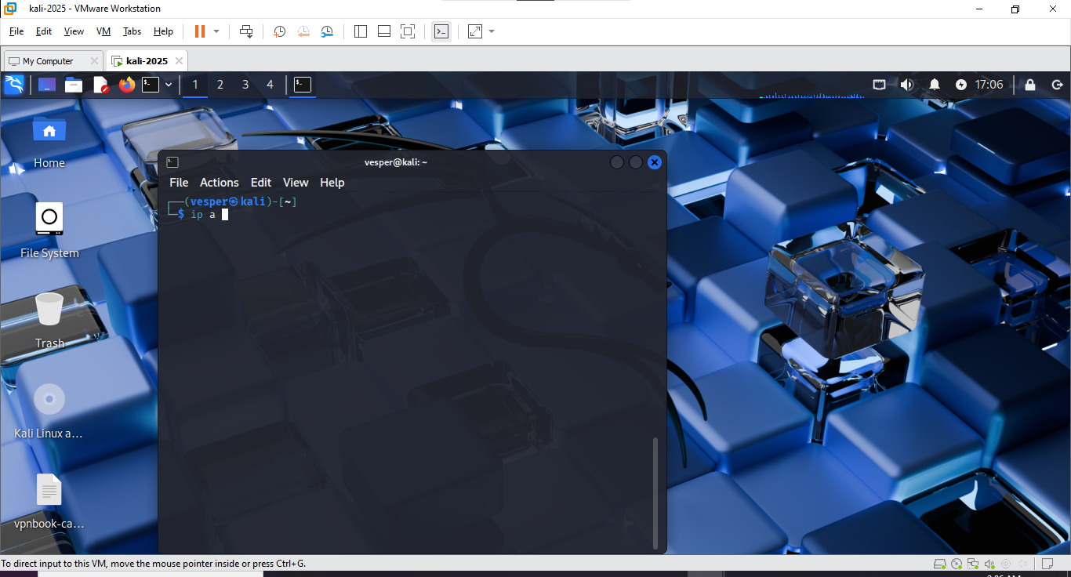
  - sudo ./macmasker.sh eth0 # for manual change
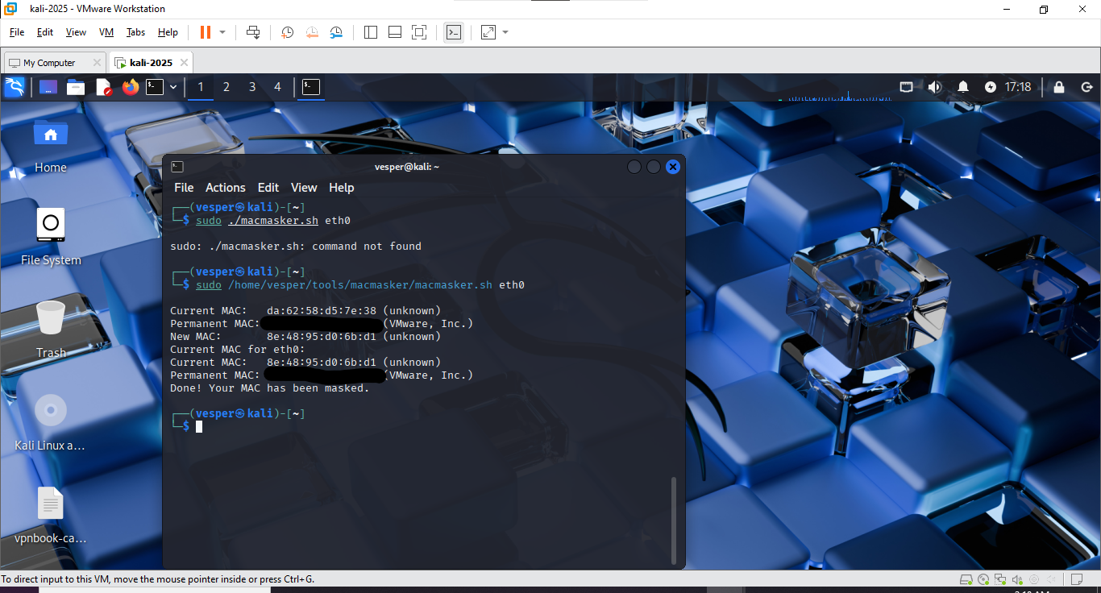
  - macchanger -s wlan0 # to verify new MAC
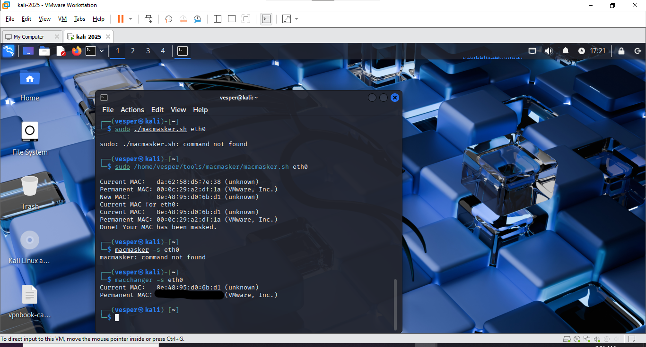
- Automation:
  - No manual intervention is needed after setup. Each network reconnection automatically triggers MAC masking.
6. Testing and Validation
Purpose: Ensure the tool functions correctly in both manual and automatic modes.
Testing Procedure
- Checked the original MAC address using:
- ip a
- Performed a manual MAC address change using the tool.
- Disconnected and reconnected the network to test automatic MAC masking.
- Verified the changed MAC address with:
- macchanger -s wlan0
- Repeated the process across multiple connect/disconnect cycles.
Results
- MAC address successfully randomized on each network connection.
- Manual masking worked reliably on demand.
- Network connectivity restored automatically after each change.
7. Outcome
- Created a functional and automated MAC masking tool.
- Improved network privacy through automated MAC rotation.
- Demonstrated skills in Bash scripting, Linux networking, and security automation.
- Tool can be reused, extended, or published as an open-source project for other cybersecurity enthusiasts.
8. Future Improvements
- Add a menu-driven interface for random/custom MAC options.
- Implement a logging system to track MAC change history.
- Provide a toggle feature to enable/disable auto-masking easily.
9. Conclusion
The Automatic MAC Address Masking Tool enhances anonymity and security by automating a common privacy task. It is lightweight, effective, and valuable for penetration testers, ethical hackers, and privacy-conscious users.

